***How to solve Big Data Problem***

***Assignment 1.2***

1.pwd

**pwd command** (print working directory) writes the full pathname of the current working directory to the standard output.





2.vi

**vi** is an text editor which is display-oriented the screen acts as a window into the file you are editing. Changes you make to the file are reflected in what you see.



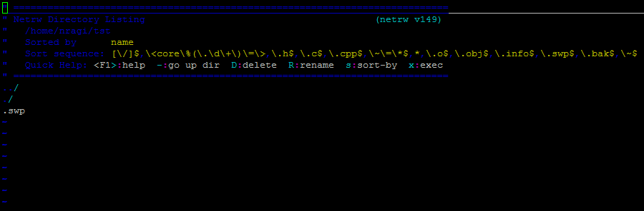

3. touch

The **touch command** is the easiest way to create new, empty files.





4.mkdir

To create a directory in Linux using the **mkdir** command .





5.rm

It helps to remove the file names but not the directories.



6.ls

**ls** is a Linux shell command that lists directory contents of files and directories.





7.echo

To display the value of a variable , we use echo command.





8.cat

**cat command** allows us to create single or multiple files, view contain of file.



As there is no data it dint display anything

9.who

Who command is used to check how many users are logged in to the machine.



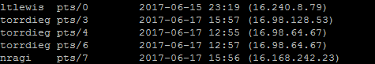

10.cd

Change directory command is used to change the current working directory.





11.date

It will display the current **date** and time.



12.cal

The **cal command** is a **command** line utility for displaying a calendar



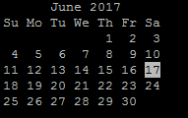

13.mv

The mv command is used to move or rename files.





**14.** cp

Copy from source to destination.





15.which

**Which command** is very small and simple **command** to locate executables in the system

